Exercise 2: Protocol Exploration & Local REST APIs
Course: Architectural Convergence in Computer Engineering: IoT, Middleware, Cloud, and Database Systems
Week: 2 (Hands-On Laboratory Exercise)

Objective: To deploy a local Node-RED middleware container, architect a RESTful HTTP server with distinct methods (GET/POST/PATCH/DELETE), monitor raw data via debugging consoles, and validate endpoint connectivity using Postman.

Step 1: Run the Node-RED Docker Image on the Local Network
To act as our local API server, we must spin up the Node-RED container we downloaded in Week 1 and expose its internal port to your computer's Local Area Network (LAN) so external devices (like Postman or an ESP32) can reach it.
- Open Docker Desktop: Ensure the Docker daemon is running in the background.
- Launch via Docker Desktop: Open your computer's Docker Desktop click the run button for the NodeRed image, and use the settings as follow:
  - Ports: The -p 1880:1880 flag is critical. It binds port 1880 inside the isolated container to port 1880 on your physical machine's LAN IP address.
  - Volumes: If you want to store your data in host rather than inside the docker itself.

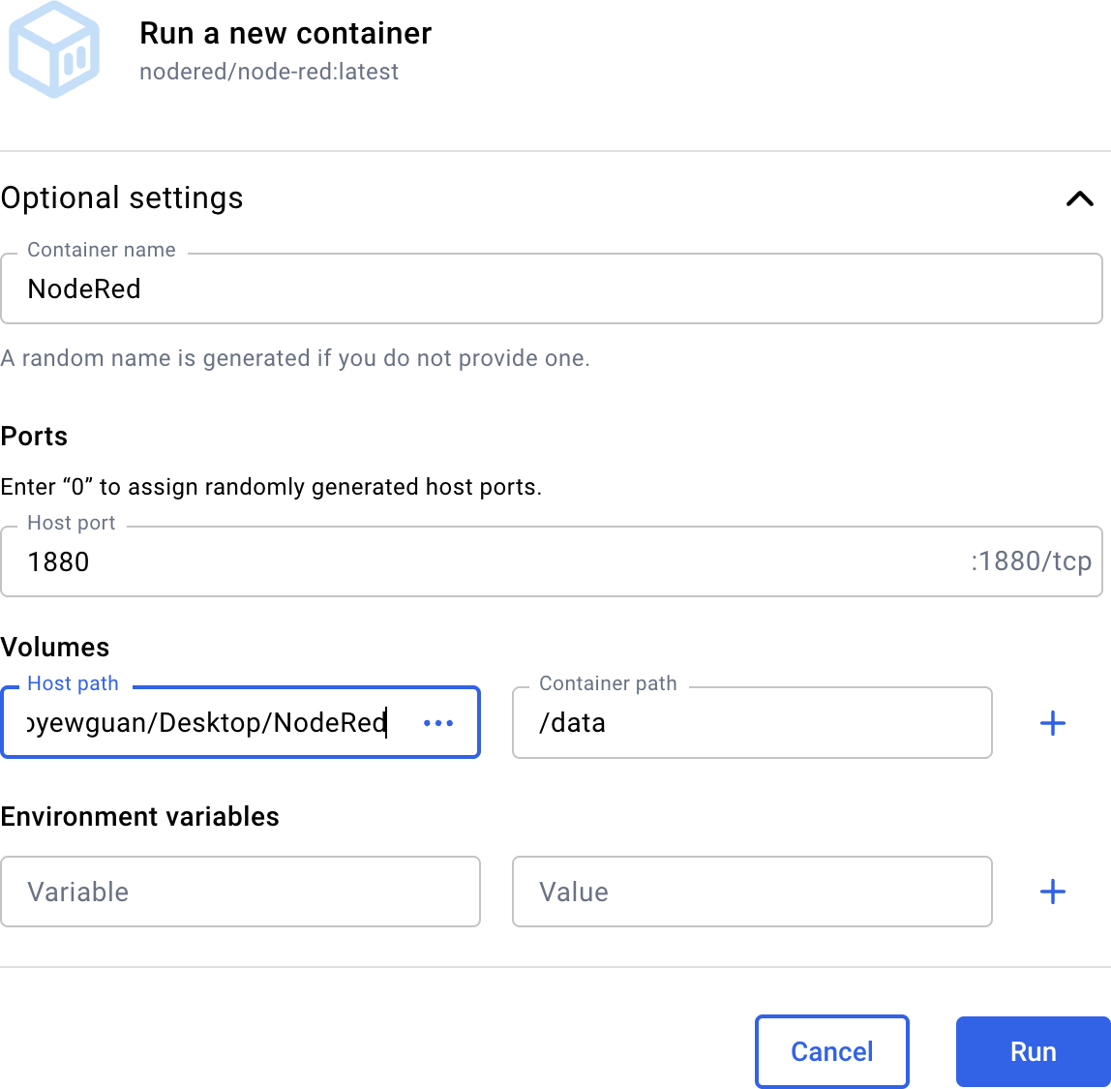

- Verify Execution:
  - Check data created in the folder of the host path that you configured
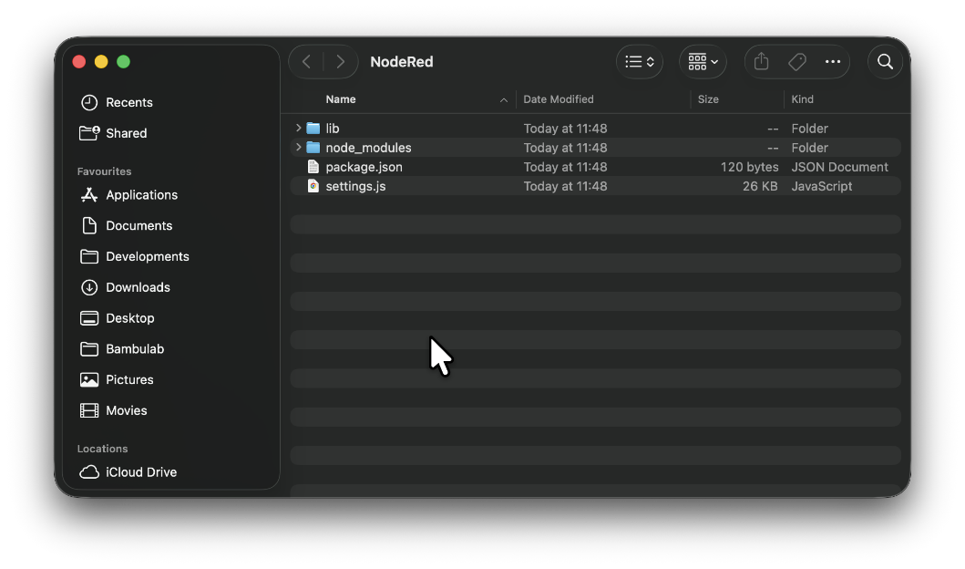

  - Open your web browser and navigate to http://localhost:1880. The Node-RED visual workspace should load.
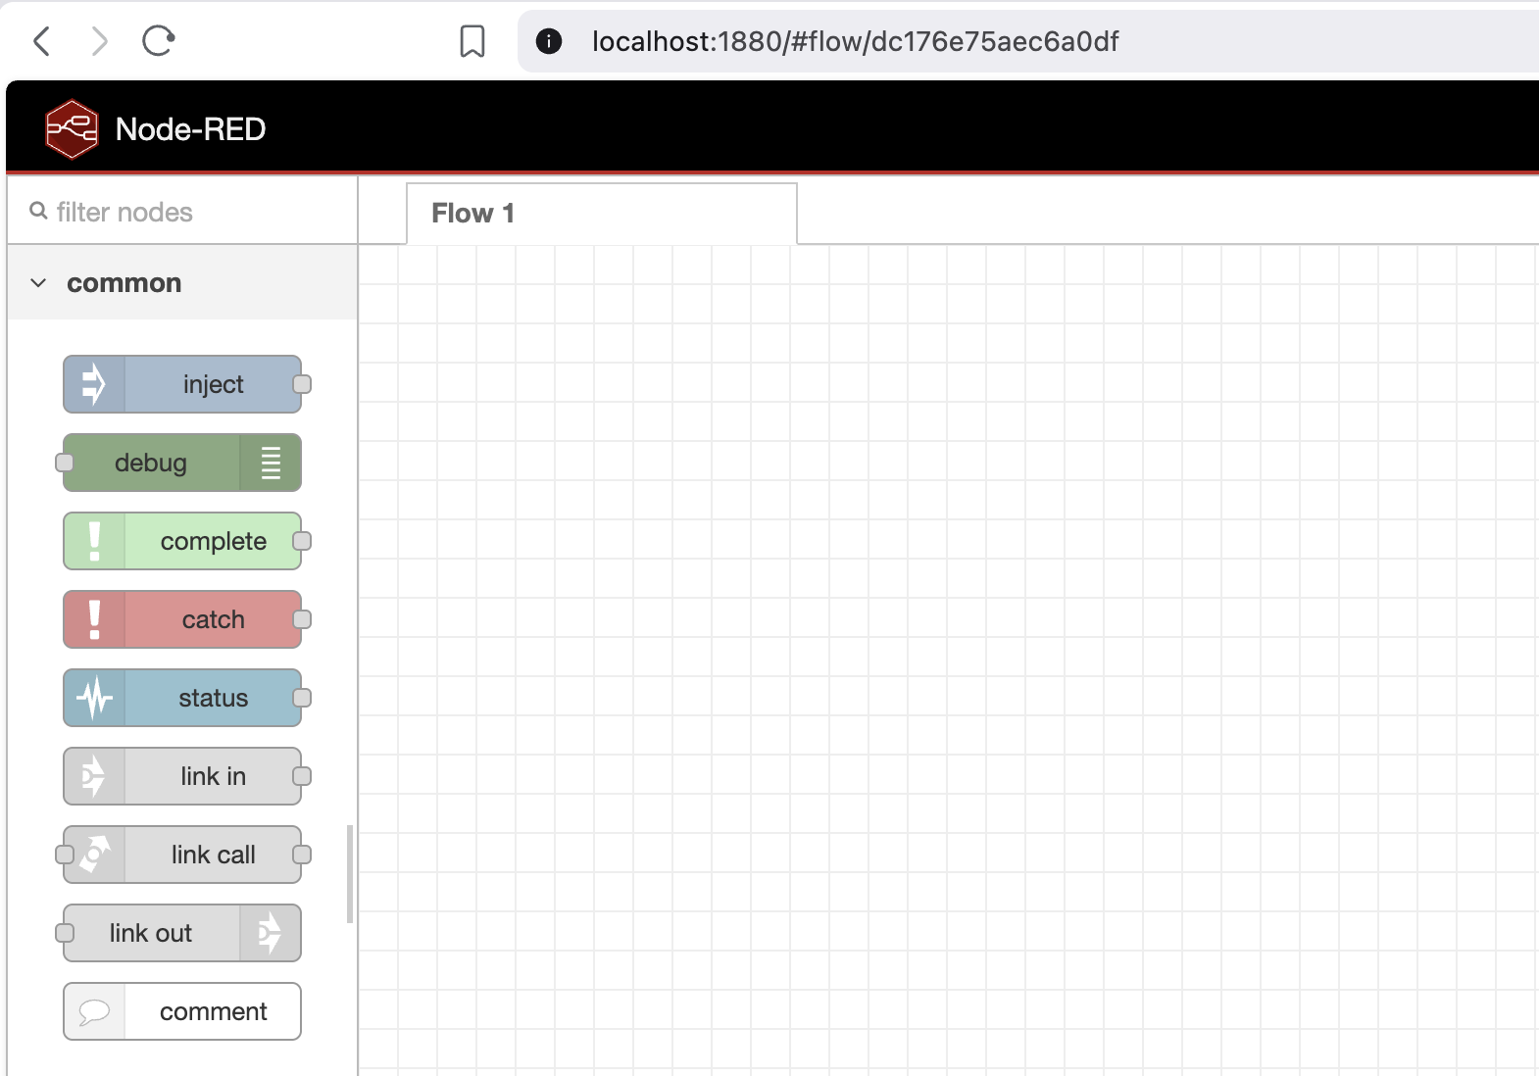

Step 2: Design Node-RED for HTTP Requests and Responses
Now we will architect a RESTful API endpoint that can receive incoming sensor telemetry via an HTTP POST request and acknowledge it.
- Add an HTTP Input Node: Drag an http in node from the left palette onto the workspace. Double-click it to configure:
  - Method: POST
  - URL: /api/sensor
  - Name: Receive Telemetry
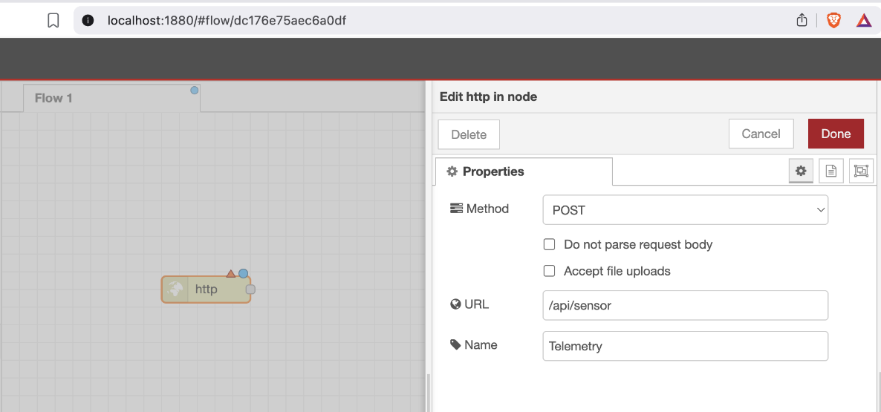
- Add an HTTP Response Node: Drag an http response node onto the workspace. This node is required to close the HTTP transaction by sending a status code back to the client. Double-click it:
  - Status Code: 200 (which signifies "OK").

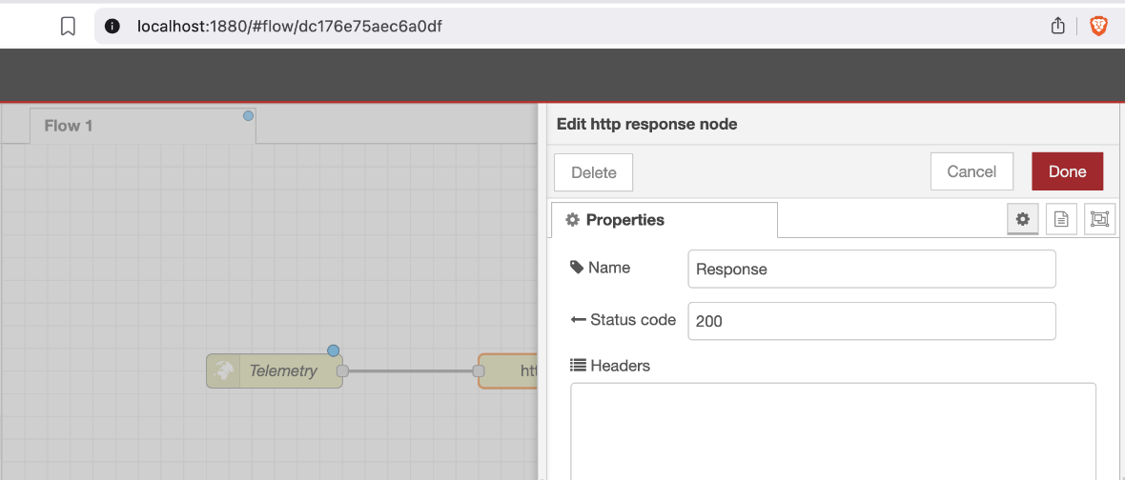

- Wire the Nodes: Click and drag a wire connecting the output port of the http in node directly to the input port of the http response node.
- Deploy: Click the red Deploy button in the top right corner to make your API go live.

Step 3: Test the Endpoint using Postman
With our server running, we will act as the client using Postman to simulate an IoT device sending telemetry data.
- Launch Postman: Open the Postman application and click New > HTTP Request.
- Configure the Request Method & URL: * Change the dropdown from GET to POST.
  - Enter your endpoint URL: http://localhost:1880/api/sensor
(Note: To test from another machine on the same network, replace 'localhost' with your computer's IPv4 address).
- Construct the JSON Payload:
  - Click the Body tab underneath the URL bar.
  - Select the raw radio button.
  - Change the text format dropdown from 'Text' to JSON.
  - Enter a simulated sensor payload: JSON
{
"sensor_id": "ESP32_01",
"temperature": 24.5,
"humidity": 60
}

- Send and Verify: Click the blue Send button.
  - In Postman: You should see a Status: 200 OK at the bottom, confirming the server received the request.
  - In Node-RED: Look at your Debug sidebar. You should see the complete JSON object you just sent successfully logged in the console!

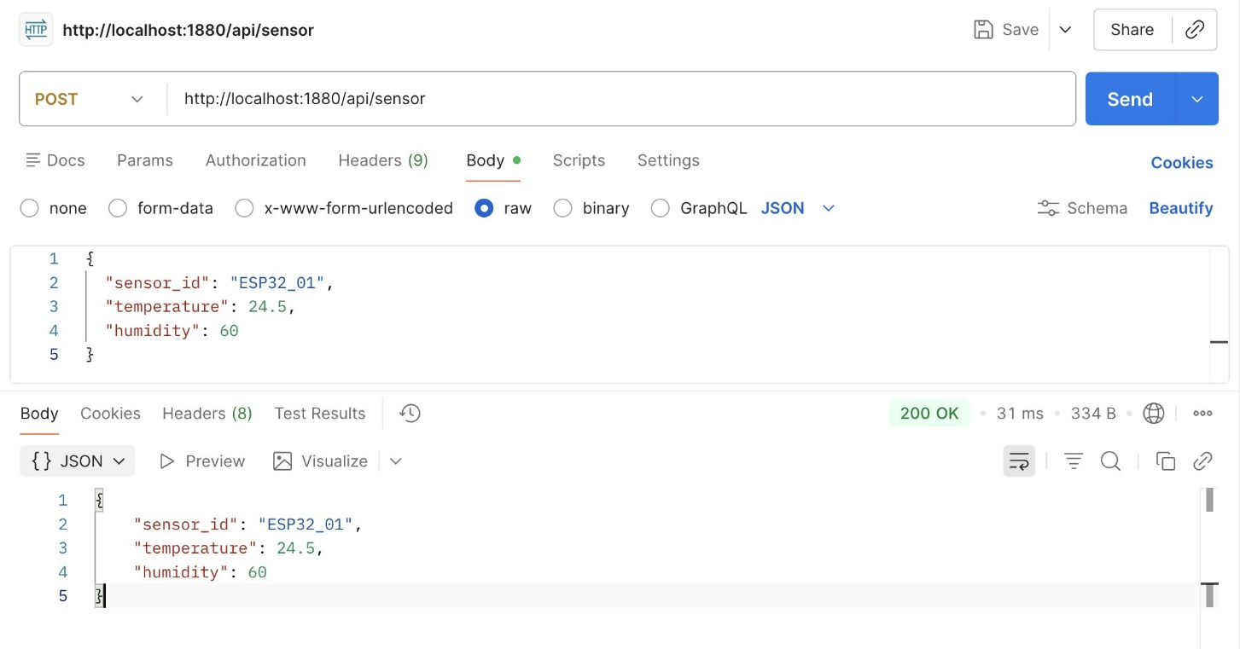

Step 4: Debugging the Node-RED Flow
In distributed systems, silent failures are dangerous. We must set up a console log to inspect the incoming HTTP payloads.
- Add a Debug Node: Drag a green debug node onto the workspace.
- Wire for Inspection: Wire the output of your http in node to the input of the debug node (it will share the connection with the response node).
- Configure Debug Output: Double-click the debug node. Change the output from msg.payload to complete msg object. This allows you to inspect the HTTP headers, the method, and the raw JSON payload.

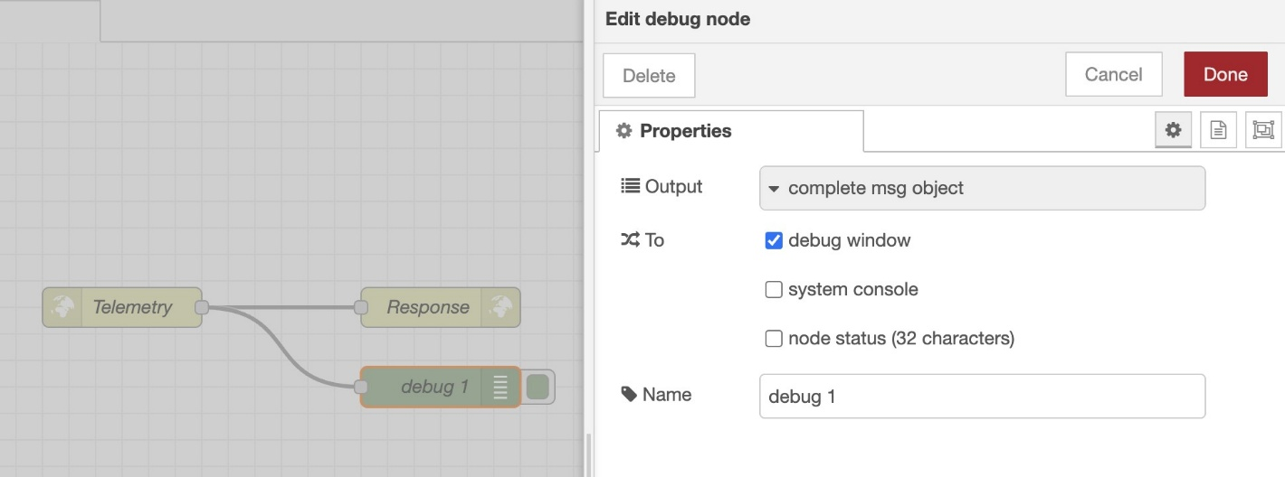

- Open the Console: Click the small "Bug" icon on the far right sidebar to open the Debug Messages panel.
- Deploy: Click Deploy again to save the debugging logic.
- Send the request again from postman, and you should able to see the debug message.
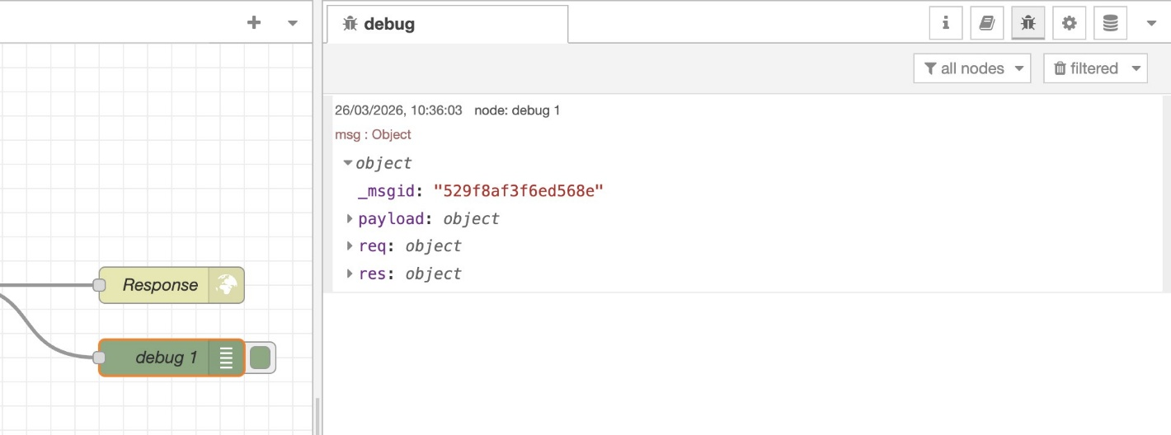

Discussion
To verify your understanding of RESTful architectures, complete the following challenges and answer the questions below.
A: HTTP Method
  - In your Node-RED workspace, duplicate your http in node and change the Method from POST to GET.
  - Add a function node in between http in, and http response. Then in the On Message tab return any JSON payload to the msg. Click Deploy.
  - In Postman, change your request method to GET and attempt to send the request.

What happened to your JSON pa yload when you switched to a GET request? Did Node-RED successfully log the temperature data in the debug window? Explain the fundamental architectural difference between how a POST request and a GET request handle data payloads.

B: Local Area Network (LAN) Edge Connectivity
Your Docker container is currently bound to your physical computer's port 1880. Let's prove that this acts as a true local edge server.
- Find your computer's local IPv4 address (e.g., 192.168.1.X) using ipconfig (Windows) or ifconfig (macOS/Linux) in your terminal.
- Ensure your smartphone is connected to the exact same Wi-Fi network as your computer.
- Open the web browser on your smartphone and type: http://[YOUR_IPV4_ADDRESS]:1880/api/sensor

Did your phone successfully trigger the Node-RED flow? Explain why you are not able to send a request to the POST method from your phone?

C: Deep Packet Inspection via Debugging
Analysing both the debug message in NodeRed for both activities A and B above, expand the entire msg object by clicking the small arrows next to the logged message.
  - Look deeply at the expanded msg.req (request) object. Identify and list the following components involved in your HTTP protocol transmission:
    - a) What is the content-type listed under the headers?
    - b) What is the IP address of the client that sent the request (look for remoteAddress)?
    - c) Compared the differences between A and B

Result:
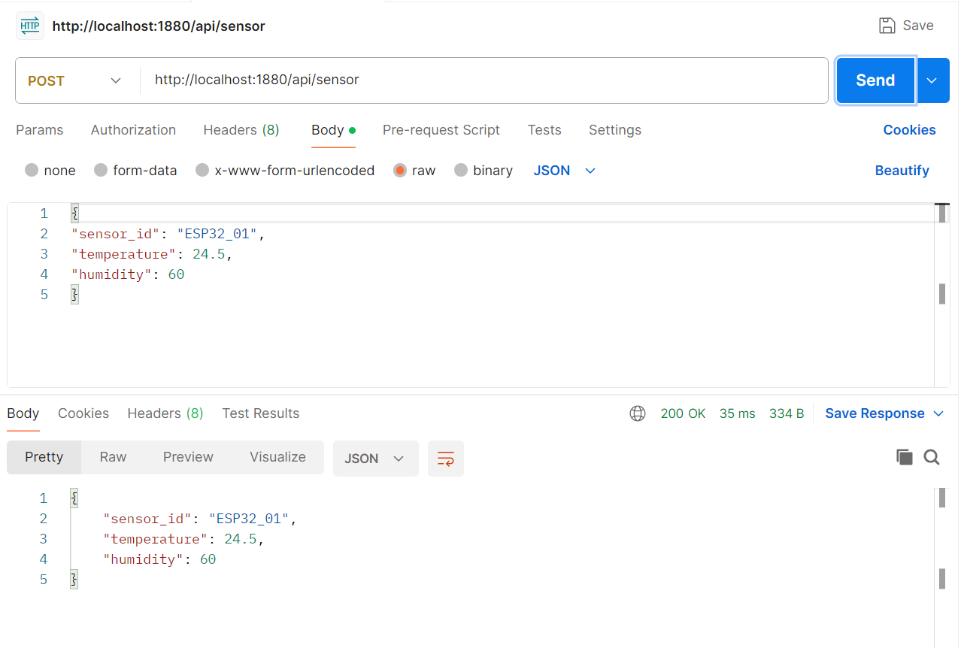
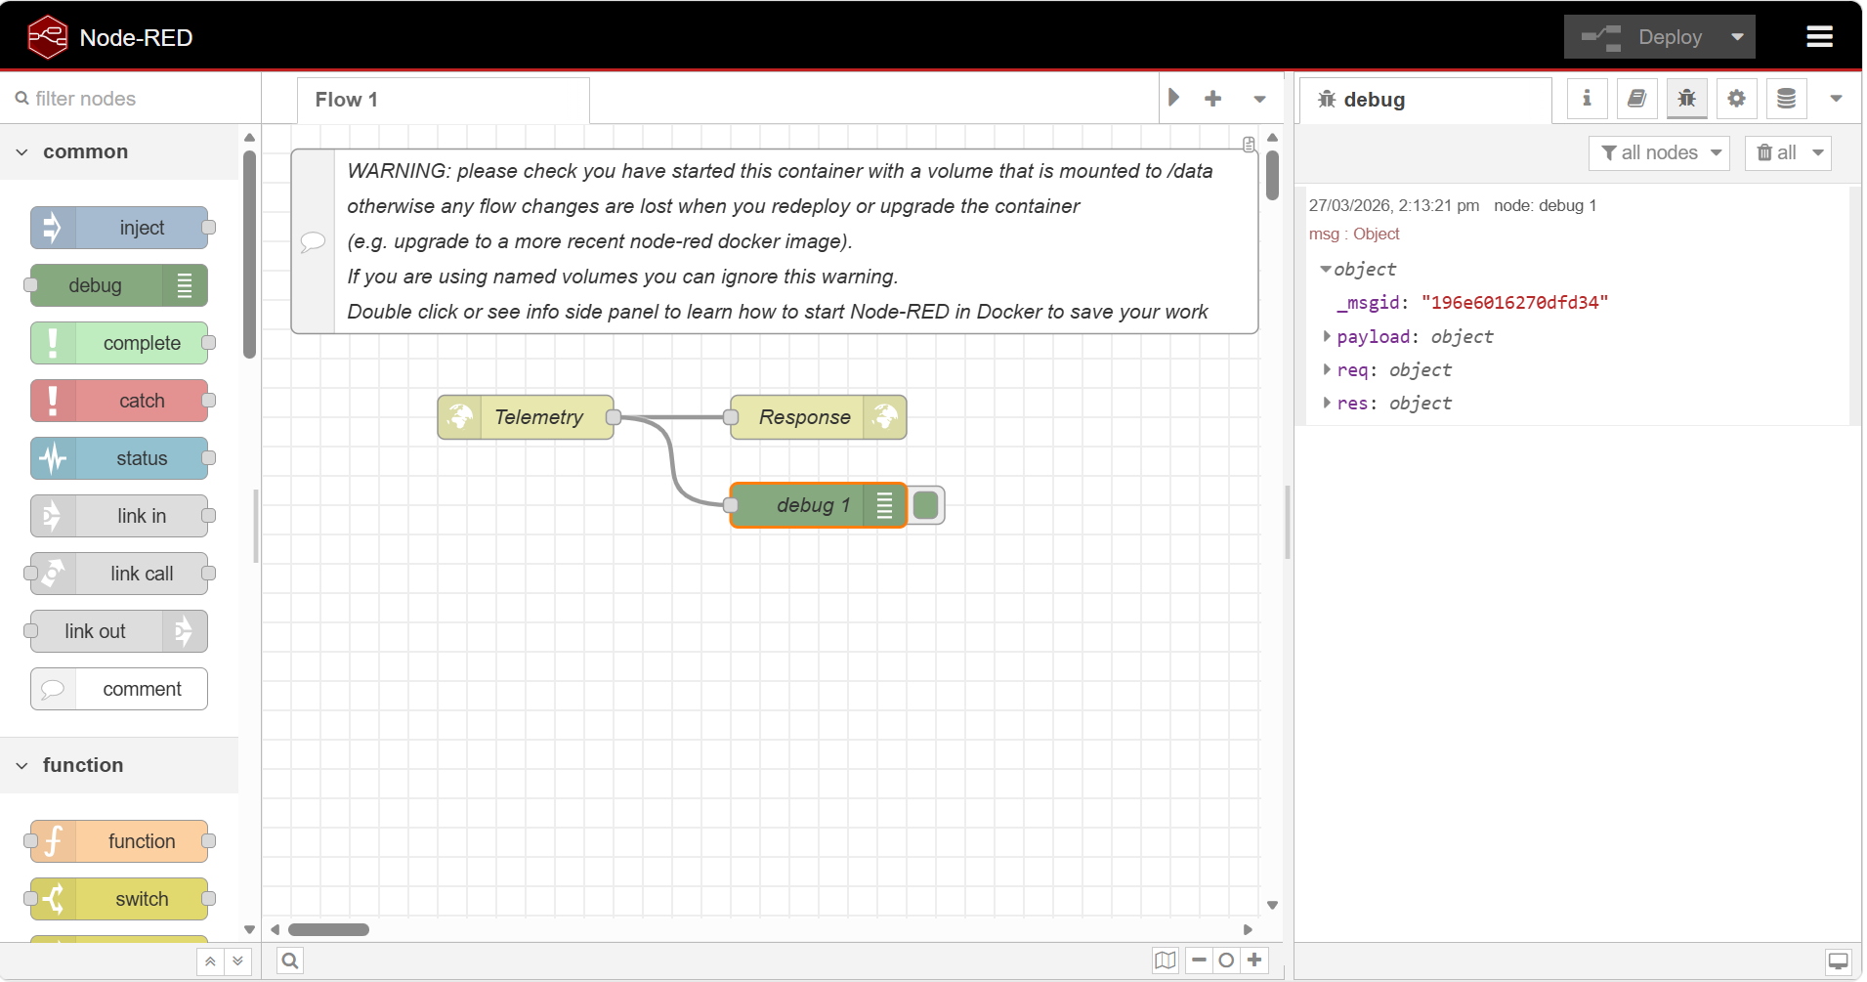

A: HTTP Method
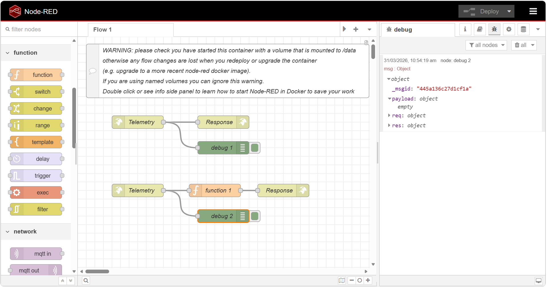
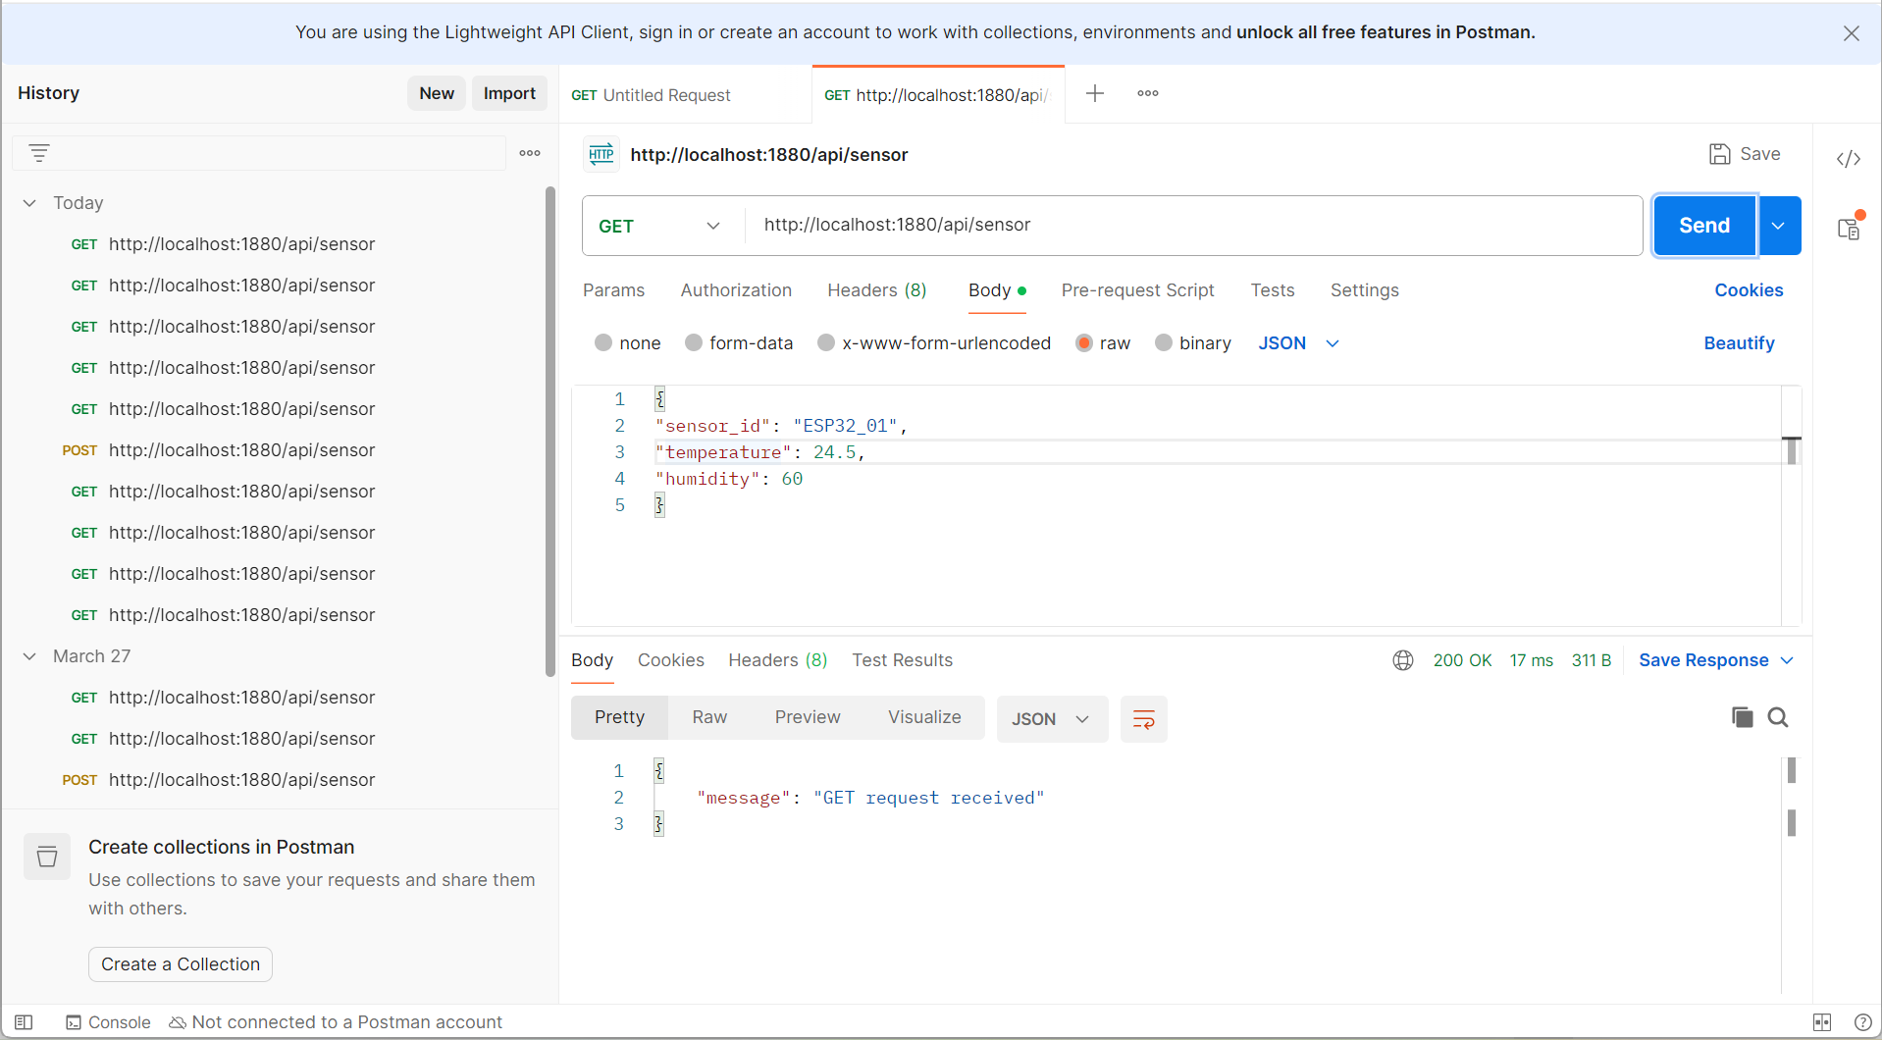

When switching from a POST request to a GET request, the JSON payload sent in the request body is no longer transmitted in the same way. In a POST request, the data is included in the HTTP request body, allowing Node-RED to receive and log the sensor values such as temperature and humidity in msg.payload.
However, when using a GET request, the request body is typically not used. Instead, data (if any) must be passed through the URL as query parameters. As a result, the JSON payload sent from Postman is not received by Node-RED, and the debug window does not display the temperature data.
This demonstrates a fundamental architectural difference:
- POST requests are designed for sending structured data to the server (e.g., IoT telemetry).
- GET requests are intended for retrieving data and do not rely on a request body.
Therefore, Node-RED does not successfully log the JSON payload when using GET, because the data is not transmitted in the expected format.

B: Local Area Network (LAN) Edge Connectivity
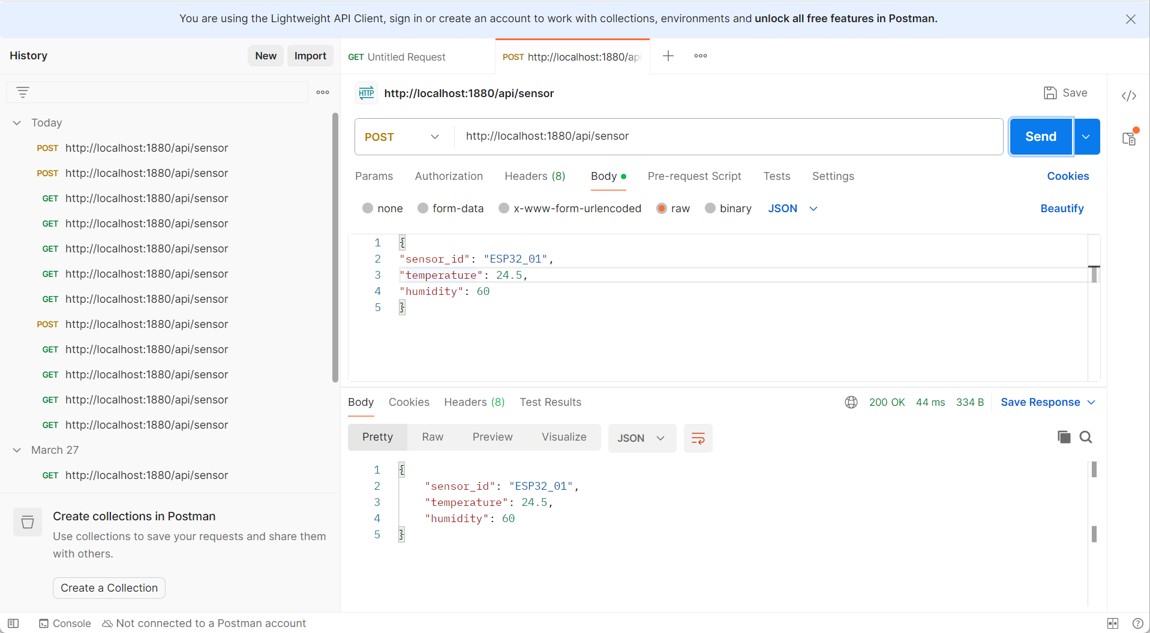
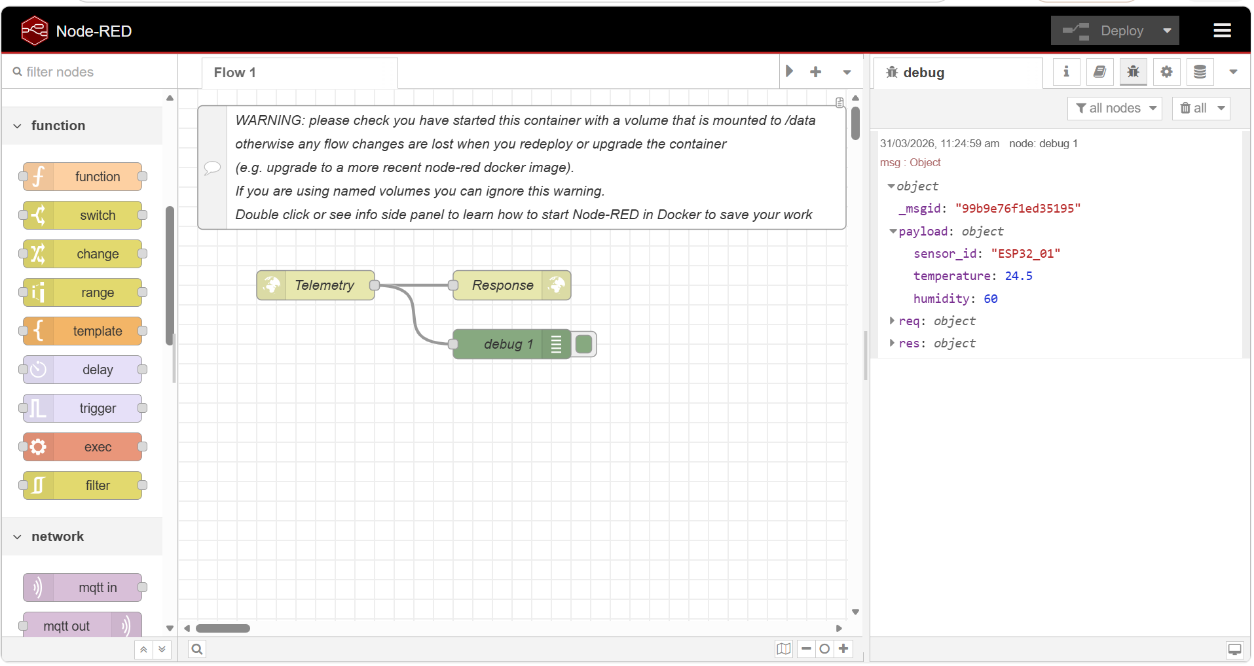
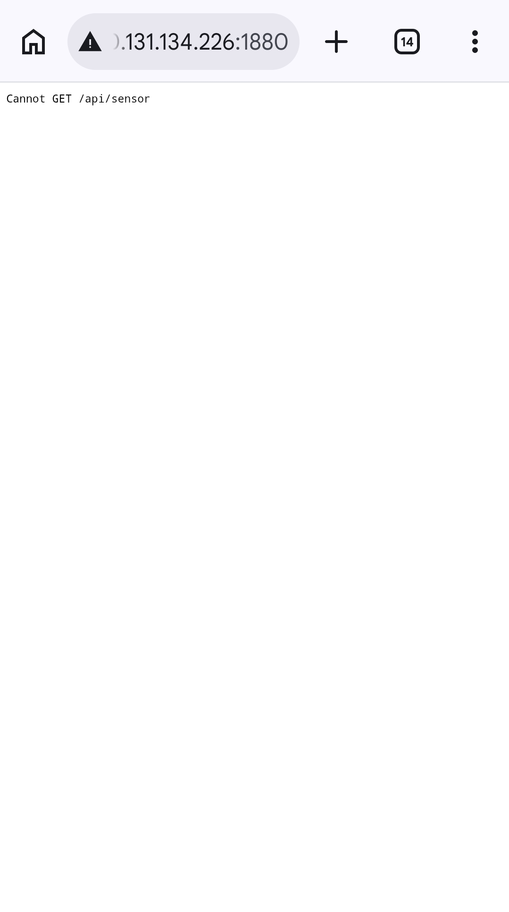
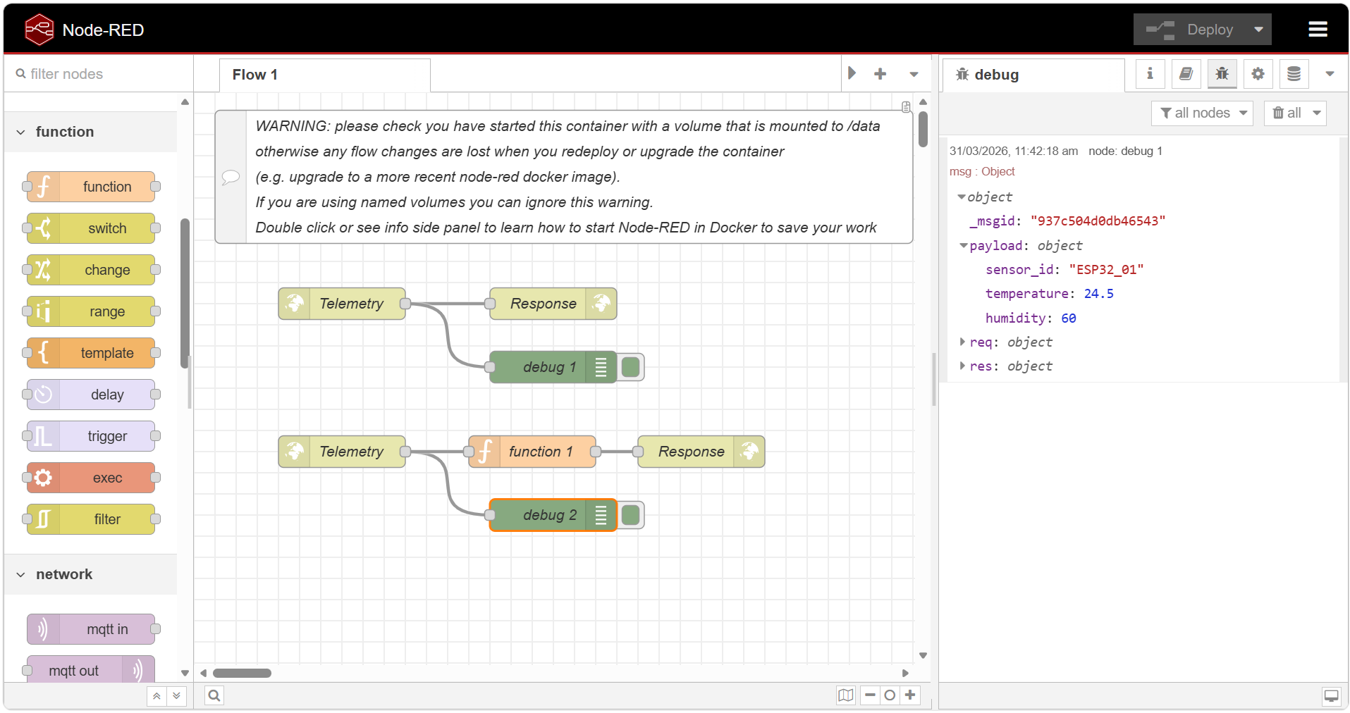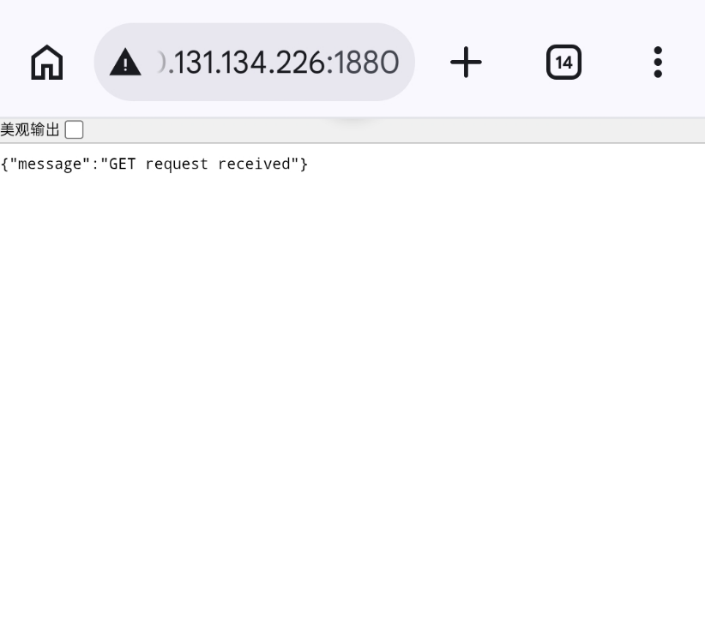
When accessing the endpoint from the smartphone browser using the computer’s IPv4 address, the message “Cannot GET /api/sensor” is displayed. This occurs because the browser automatically sends a GET request, while the Node-RED flow is configured to handle only POST requests.
Since RESTful APIs differentiate endpoints based on both the HTTP method and the URL, the server does not recognize a GET request for the same path and returns an error.
This experiment confirms that the Node-RED server is successfully accessible over the Local Area Network (LAN), as the smartphone is able to reach the server. However, a browser cannot send POST requests with JSON payloads directly, which prevents it from interacting with the POST-only endpoint.

C: Deep Packet Inspection via Debugging
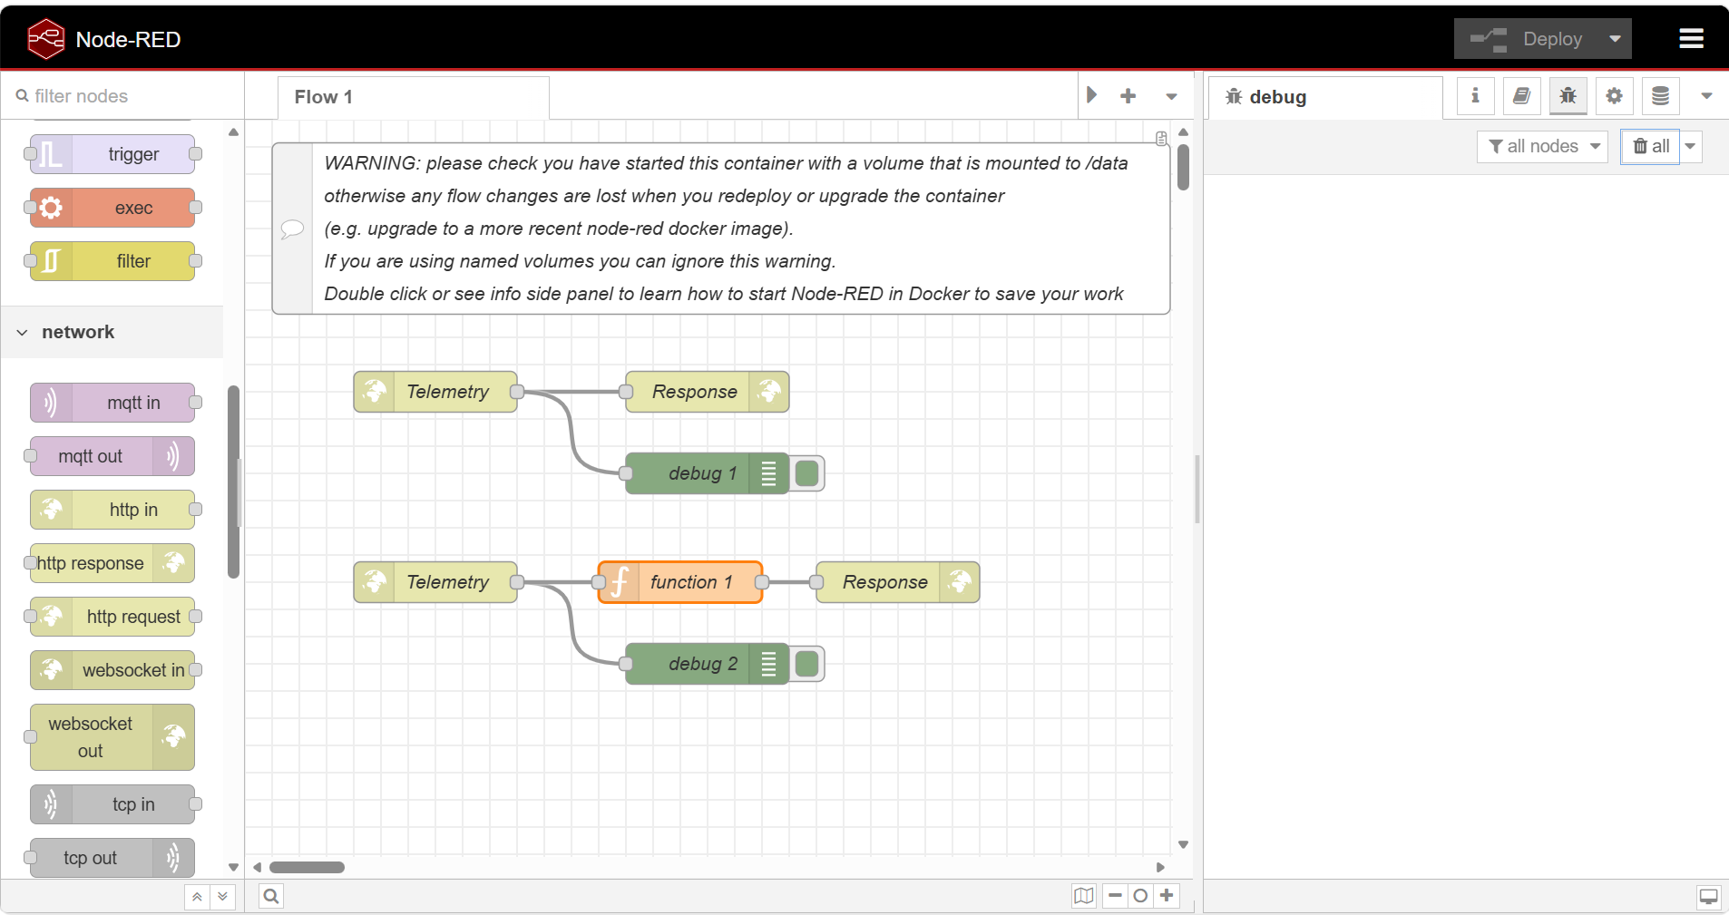
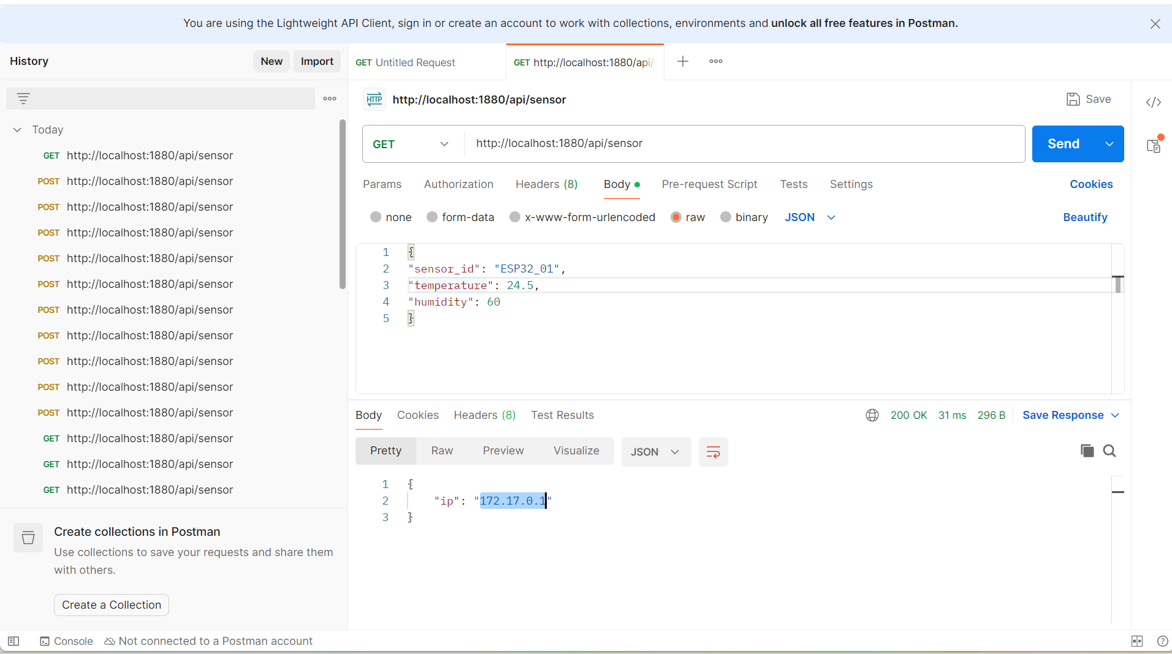
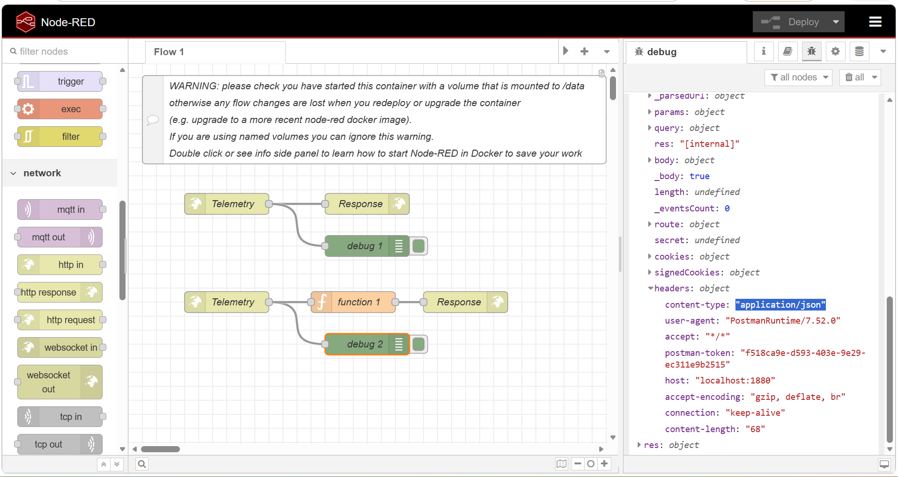
- The content-type is application/json.
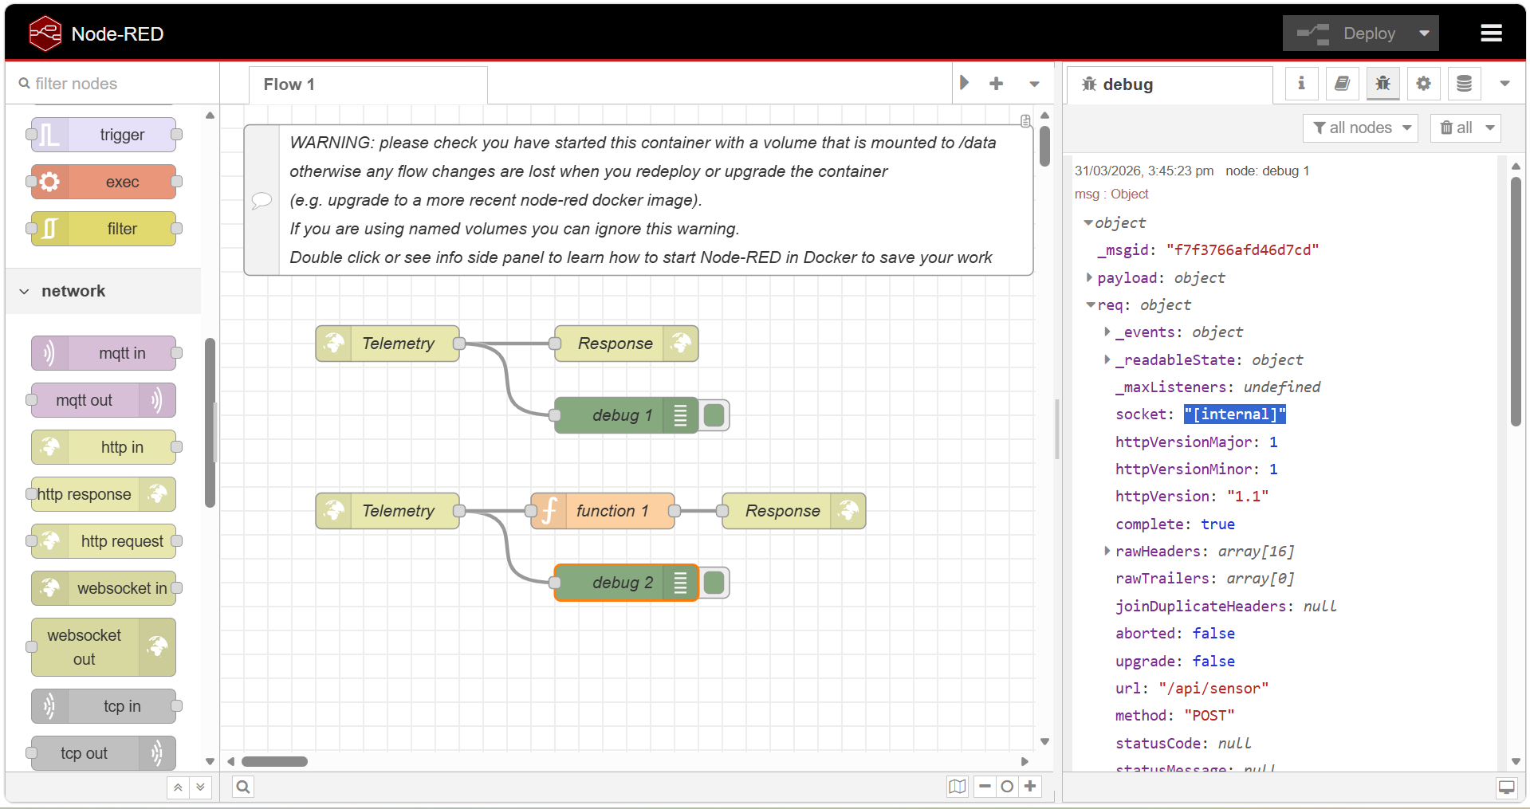
- The remote Address field shows [internal] instead of a real IP address because Node-RED is running inside a Docker container. Docker uses an internal bridge network, which masks the actual client IP address and replaces it with an internal identifier.

- The debug output shows clear differences between A and B. In activity A, Postman allows both POST and GET methods, where POST successfully transmits a JSON payload that appears in msg.payload, while GET does not include a request body. In contrast, activity B (smartphone browser) only sends a GET request, so no JSON payload is received by Node-RED.
Additionally, the headers differ: Postman includes application/json for POST requests, while the browser sends standard web headers such as text/html. The client IP address also differs, where Postman traffic appears as localhost or internal Docker network, while the smartphone represents an external LAN device, although Docker may mask the real IP address.
Overall, this demonstrates differences in HTTP methods, payload handling, headers, and client origin between API tools (Postman) and standard web browsers.

